Innovation Incentive Competition Application
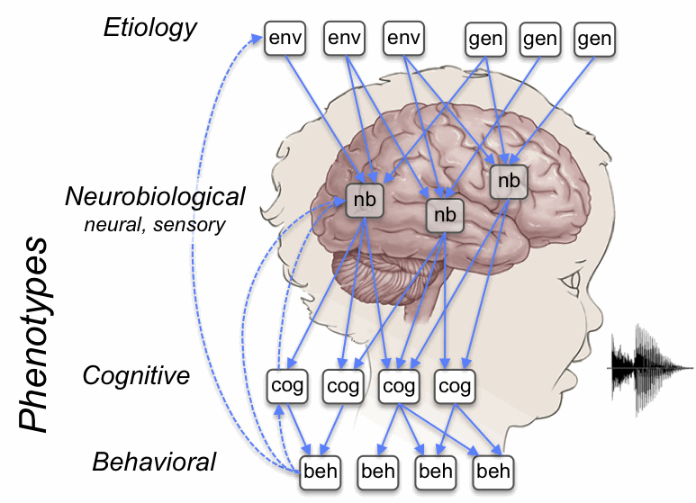

IGERT: Language Plasticity

Genes, Brain, Cognition, Computation

INSTRUCTIONS: Complete this form and email it to Nicole Landi.

DATE : Name of principal investigator (applicant):
PI is: IGERT Fellow , IGERT Affiliate

Name of proposal (make this descriptive, so the casual reader understand your goal from the title)

Total funds requested $:
Requested start date: Expected completion date:

Note: Most grants are in the range of $100 to $2,000, but affiliates can apply for up to $5,000 and fellows up to $10,000.

Is this an individual or team application? Individual or Team
If Team, list members, and specify whether they are students or faculty

Ethics approval: Does your project require ethics approval (for human or animal subjects)? YES NO
Skip the rest of this section if the project does not require ethics approval

Have you already obtained approval? YES, ethics approval #: , and expiration date:

If you require but do not yet have ethics approval, indicate when your protocol was / will be submitted for ethics approval:

Note that if your application is successful, no funds will be provided to you until you have all required ethics approvals.
Please complete each of the following items concisely.

Short project abstract (about 100-200 words):

Project description and predictions. This does not need to be very detailed, but you do need to describe the purpose of the project and how it will be achieved (2 paragraphs). Also, provide an estimated timeline of project activities (e.g., by when do you expect to collect data?):

Innovation. A good starting point for thinking about innovation in science is the "Final report from the NSF innovation and discovery workshop" (Schunn et al., 2007, URL: http://www.nsf.gov/pubs/2007/nsf0725/nsf0725.pdf). Explain how your project is innovative. This could, for example, take the form of a description of how the ideas significantly push boundaries that people have been unable or unwilling to push before; or it could emphasize the unusual nature of the collaboration that you propose and the way you plan to achieve communication between contributors. These cases are meant as examples, but are not meant to be restrictive, so other approaches to innovation are welcomed. (1 paragraph):

Connection to IGERT goals. How does your project relate to overall IGERT goals or to specific subgoals (such as promoting diversity, creativity, innovation, research topics etc.)? (1 paragraph):

Works cited.

Likely research or other products. Innovation projects do not need to result in journal articles or conference presentations, but it is good for you and for our IGERT when that happens. What research (or other) products could result from your project? (1 or 2 sentences, indicating planned outlets and topics---this may change once you start the project, but the point of this question is to encourage thinking ahead of time about this)

Budget and justification. You do not need to fully itemize except in the case of equipment. You can supply a short summary justification rather than an item-by-item justification. Also, provide an estimated timeline of spending (e.g., by when do you expect to expend all equipment costs?).

NOTE: Upon completion of the innovation application, a brief (~1-2 paragraph) completion report describing what activities were completed, and what products were yielded, should be sent to Nicole Landi (this will assist with the annual NSF progress report).

