Revised 2017.09. 24
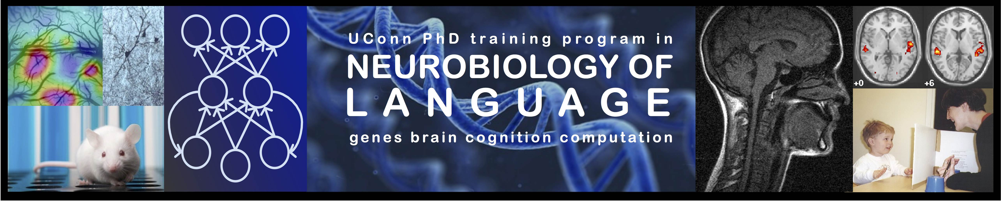

Innovation Incentive Competition Application

Important information about IIC funds

Beginning in Fall, 2017, our IIC funding is significantly reduced. We anticipate having approximately $20,000 per year for 2017-18 and 2018-19, and funding beyond 2018-19 is uncertain. As such, IIC will be more competitive than in past years. Highest priority will be given to innovative activities. In order, IIC priorities will be:
- Pilot funds to support new research ideas proposed by a team involving NBL trainees from at least 2 PhD programs (note that divisions in Psychological Sciences have different PhD programs)
- Pilot funds to support new research ideas proposed by a team including at least one NBL trainee and a faculty member from a different PhD program
- Pilot funds to support new research proposed by a single NBL trainee
- Funding to organize training not available at UConn by brining external personnel to UConn, provided it benefits the broader NBL community
- Funding to travel for training not available at UConn, with higher priority for training that will have benefits to NBL personnel in addition to the trainee who travels
- Conference travel will be funded occasionally, but only when: (1) a compelling rationale for innovative outcomes is provided, and (2) the trainee seeks other funding first and is unable to obtain sufficient funding from sources such as advisors, faculty co-authors, departments, or the graduate school. Highest priority will be given to trainee talks or posters where the trainee is the primary presenter. We typically will not support secondary co-authors or more than one trainee per presentation.

Note that a separate fund is available for current or former IGERT fellows for international research experience collaborations. These funds are meant to support extended visits where you are actually a resident researcher in your collaborator's lab for at least approximately 2 weeks. Much longer visits are possible. Use this form to apply for international experience funds. Associates may apply for similar experiences using a standard IIC application, but these funds are more limited.

INSTRUCTIONS: Complete this form and email it to Nicole Landi <nicole.landi@uconn.edu>

DATE Applicant

Current or former IGERT Fellow? YES

Name of proposal (make this descriptive, so the casual reader understand your goal from the title)

Total funds requested Requested start date Expected completion date

Note: Most grants are in the range of $100 to $2,000. With exceptional justification, larger amounts will be considered, especially for team applications involving trainees from more than one PhD program.

Is this an individual or team application? Individual or Team
If Team, list members, and specify whether they are students or faculty (e.g., Henry James (S), William James (F))

Ethics approval: Does your project require ethics approval (for human or animal subjects)? YES NO

Skip the rest of this section if the project does not require ethics approval

Have you already obtained approval? YES, ethics approval #: and expiration date

If you require but do not yet have ethics approval, indicate when your protocol was / will be submitted for ethics approval:

Note that if your application is successful, no funds will be provided to you until you have all required ethics approvals.

Conference/workshop travel: Is this proposal for conference/workshop travel (without any other innovative component, such as training)? YES NO

Skip the rest of this section if this is not a travel request

Have you sought funding from your advisor?
YES, amount available:
Have you sought funding from any other faculty co-author?
N/A YES, amount available:
Have you sought funding from your department?
YES, amount available:
Have you sought funding from the Graduate School?
N/A (annual limit reached) YES, amount available:
Have you sought funding from any other possible source (e.g., if the meeting offers travel grants to students)?
N/A YES, amount available:
Total funds available from other sources:
Total amount requested from NBL:
Are you presenting at the conference: YES, primary presenter; YES, secondary presenter;

Conference / workshop title:
Location:
Conference presentation citation (in APA form), including title and all authors.

International experience: Is this proposal for an international research experience (see p. 1) YES
Make sure your details below include information about the duration of the visit and the goals you have set for your collaboration.
Remember, there are separate funds set aside for international research experience trips by current or former IGERT fellows. Associates may apply for similar experiences using standard IIC funds.

Please complete each of the following items concisely.

Short project abstract (about 100-200 words):

Project description and predictions. This does not need to be very detailed, but you do need to describe the purpose of the project and how it will be achieved (1-2 paragraphs). Also, provide an estimated timeline of project activities (e.g., by when do you expect to collect data?):

Innovation. A good starting point for thinking about innovation in science is the "Final report from the NSF innovation and discovery workshop" (Schunn et al., 2007, URL: http://www.nsf.gov/pubs/2007/nsf0725/nsf0725.pdf). Explain how your project is innovative. This could, for example, take the form of a description of how the ideas significantly push boundaries that people have been unable or unwilling to push before; or it could emphasize the unusual nature of the collaboration that you propose and the way you plan to achieve communication between contributors. These cases are meant as examples, but are not meant to be restrictive, so other approaches to innovation are welcomed. (1 paragraph):

Connection to IGERT goals. How does your project relate to overall IGERT goals or to specific subgoals (such as promoting diversity, creativity, innovation, research topics etc.)? (1 paragraph):

Works cited.

Likely research or other products. Innovation projects do not need to result in journal articles or conference presentations, but it is good for you and for our IGERT when that happens. What research (or other) products could result from your project? (1 or 2 sentences, indicating planned outlets and topics---this may change once you start the project, but the point of this question is to encourage thinking ahead of time about this)

Budget and justification. Supply a short itemized budget. Also, provide an estimated timeline of spending. Note that you are typically expected to use funds within one to two semesters.

NOTE: Upon completion of the innovation application, a brief (~1-2 paragraph) completion report describing what activities were completed, and what products were yielded, should be sent to Nicole Landi (this will assist with the annual NSF progress report).

